Project Title

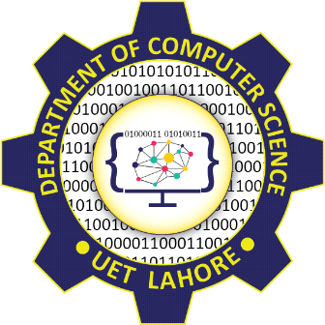
Session 2024 - 2028

Submitted by:
Name 1 2024-CS-xx
` Name 2 2024-CS-xx
Name 3 2024-CS-xx
Name 4 2024-CS-xx

Supervised by:
Syed Tehseen Ul Hasan Shah

Subject:
CSC-205L Computer Organization & Assembly Language

Department of Computer Science
University of Engineering and Technology Lahore
Lahore Pakistan

Abstract:

Introduction:

Methodology:

Implementation:

Code:

Data Flow Diagram (DFD):

Flowchart:

Circuit Diagram:

Future Works:

Project links:
LinkedIn Post Link:

References:

